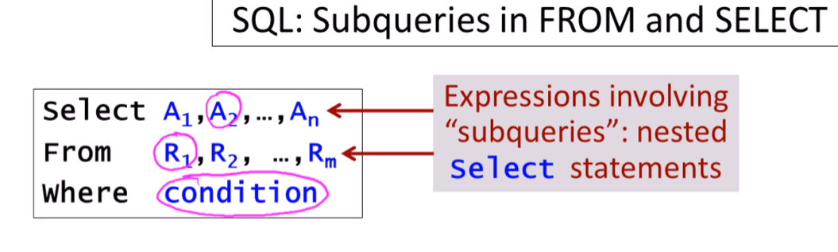

**USING subquery in the FROM Clause**

Initial query:

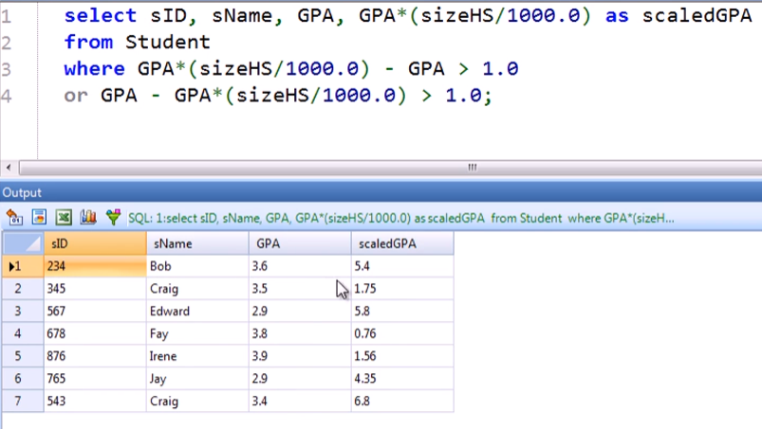

Simplifying using **abs** in the query above:

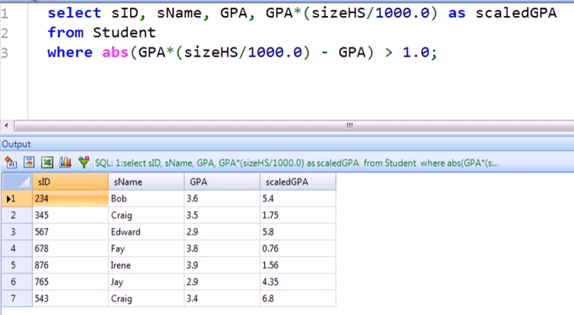

Simplifying more (removing the redundant GPA*(sizeHS/1000.0)) using subquery in FROM:

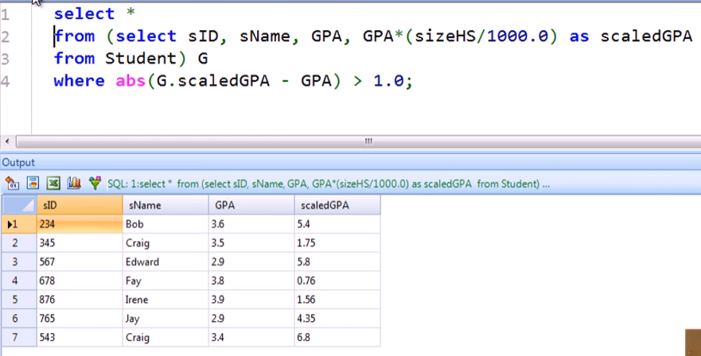

**USING subquery in the SELECT Clause** 

Initial query:

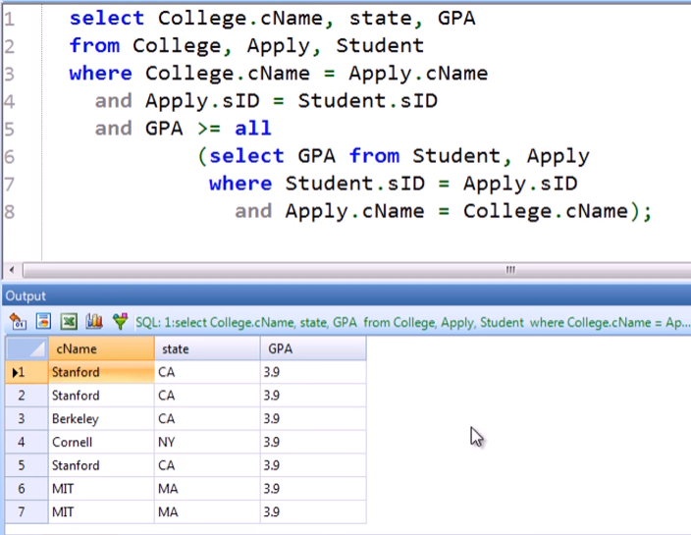

With distinct:

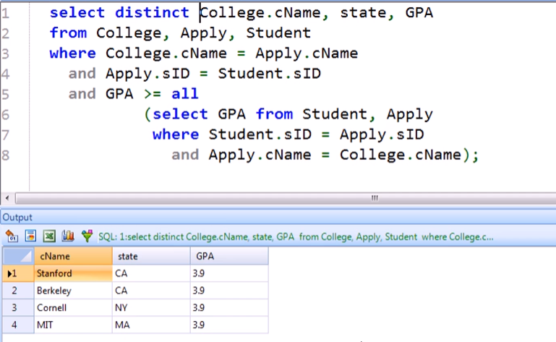

Using a subquery in the SELECT clause:

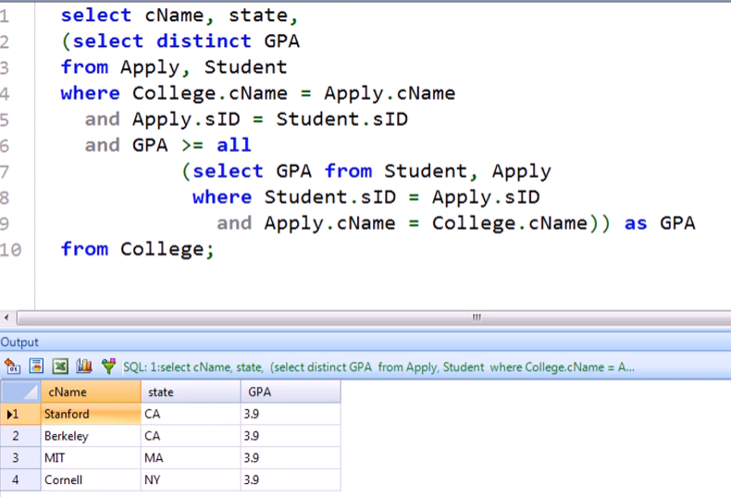

Colleges paired with the names of the applicant:

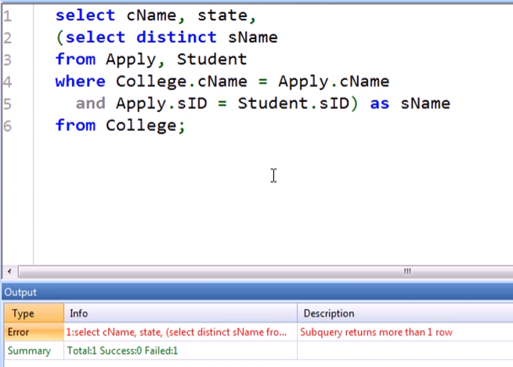

* If you are using a subquery in the SELECT clause, it should always return exactly 1 row because it should fill up only one column
* In this case, there are several student names. The example earlier only got 1 row because it only gets the highest GPA